**Altools 0.1 manual**

**What is Altools**

Altools is a suite of programs designed for the elaboration of NGS data. The software will guide the user through several tasks such as reads alig nment of a target genome (TG) on a reference genome (RG), polymorphisms calling and detection of common structural variations such as large deletions, copy number variations (CNV) and presence/absence variations (PAV).

Atools features a graphical user interface (GUI, figure 1) that allows it to be used even with no (or very small) previous experience with the Unix terminal. The installation procedure is also kept as easy as possible. Just a few system requirements and you are ready to start…….

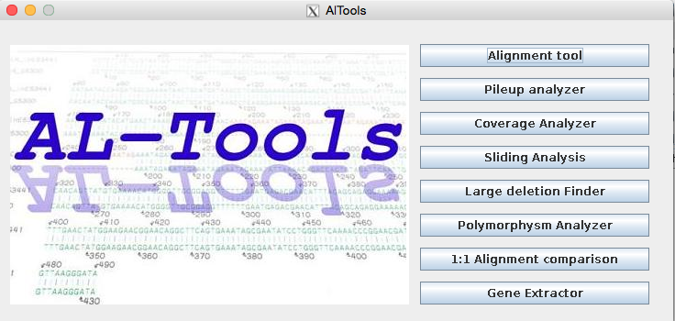

**Figure 1:** Altools main window.

**System requirement**

Altools will generate several plots by using R scripts and for this reason R must be installed on the machine running the software. For installing R on your computer please refer to the page <http://cran.ms.unimelb.edu.au> .

The software uses an R package called dnacopy to investigate the copy number variations and for this reason such a software must be installed on your machine as well. In order to install dnacopy open a terminal on your machine and type the following (in succession):

>R

>source("http://bioconductor.org/biocLite.R")

>biocLite("DNAcopy")

……. That’s it!

Altools uses also the softwares bwa, samtools and Varscan. Such tools are already included in the main Altools folder. If you want you can replace them the with the latest versions, however care must be taken in naming them exactly as they are at the moment of Altools download (e.g. just bwa, samtools, blastall, blastn, VarScan.jar).

Finally care must be taken in choosing the file and folder names. Altools is written in Java and C++, two languages that may have problem handling spaces. For this reason all folders (including the path to them) and files should not contain spaces within their names.

**Alignment and pileup**

In this section the reads from a target genome will be aligned on a reference genome by using the bwa program (figure 2). The reference will be indexed and the software will generate a samtools formatted (.sam) alignment file together with the corresponding binary format “.bam” file. The bam file (advantageous since it allows a quickest access to the alignment data) will be sorted by chromosome position and elaborated by the samtools program that will generate a pileup file that will represent the starting point of some of the downstream elaborations. The pileup file will report information such as chromosome, position, base on reference, base called, and quality of the reads that aligned at each position).

In the Alignment tool GUI you should select the folder containing the fastq formatted reads, the fasta formatted reference file, the output folder and a valid output file name. Just a few words about the reads folder. Files in such folder can only end with suffixes “_1.fastq” or (if a paired ends resequencing has been performed) “_2.fastq”. Altools will recognize potential paired end files by their name (e.g. SequencingHS_1.fastq and SequencingHS_2.fastq). File ending with “_1.fastq” and without the corresponding “_2.fastq” mate will be treated as single end. In case a paired ends experiments are submitted to Altools the paired sequence must follow the same order in files _1.fastq and _2.fastq.

You can change 3 parameters for the alignment process: (a) the edit distance, (b) the number of threads and (c) any additional align parameters for the bwa software (please refer to the bwa at <http://bio-bwa.sourceforge.net/bwa.shtml> manual for more details). Additional parameters should be inserted by using the corresponding flags and values separated by spaces (e.g. “–i 4 –o 2”, without quotes). Finally you can decide to tick the “Reads are paired” checkbox. Doing so all the paired ends reads will be aligned accordingly, otherwise all the files in the reads folder will be treated as single end reads.

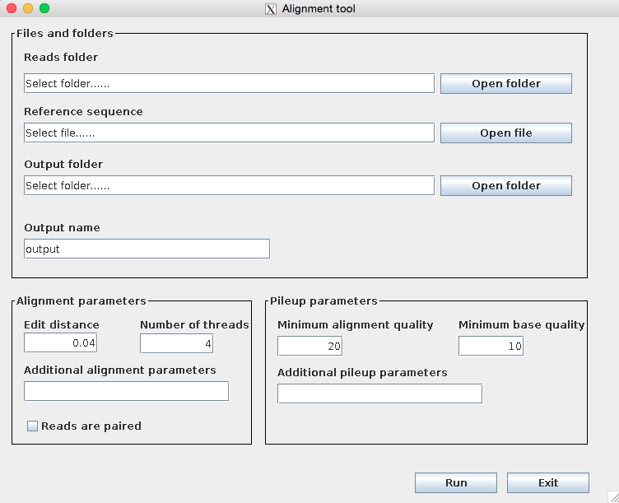

**Figure 2:** Reads alignment GUI

You can also tune the samtools pileup generation process by choosing (a) the minimum alignment quality, (b) the minimum base quality and (c) any additional pileup samtools parameters, again by using the corresponding flags and values separated by spaces (please refer to the samtools manual at <http://www.htslib.org/doc/samtools.html> for more details).

In the output folder 4 subdirectories will be generated: (a) Sam where all the sam files will be stored, (b) Bam where all the bam files will be stored, (c) indexedReference where reference indexing files will be stored and (d) Pileup where the pileup file will be stored.

**Pileup analyser**

This program (figure 3) will generate a pileup folder where coverage, SNPs and INDELs info will be sorted in a simple and lightweight format. Most of the remaining Altools software will work on this folder. This tool takes in input a pileup file that has been generated during the alignment step.

You can choose the output folder where the pileup information and the main statistics will be stored. Varscan is used to call SNPs and INDELs that are statistically significant before creating the pileup folder. Moreover several parameters can be tuned to select only aligned reads that respect specific user defined constraints. These are the Average quality, the reference coverage, the minimum allele frequency, the pvalue for the call of SNPs and INDELs, the minimum coverage to call a SNP (or INDEL) and the minimum number of reads calling a specific SNP (or INDEL). As a way of example, if the default values are selected (Figure 3) then only bases featuring a minimum quality of 30 will be used to generate the data contained in the pileup folder; position with a coverage lower than 5 will be considered not covered; only SNPs and INDELs that are called with a pValue < 0.05, refer to a position that is covered with at least 5 reads and, among these, 5 reads confirm the polymorphism (therefore only homozygous polymorphisms) will be reported in the pileup folder.

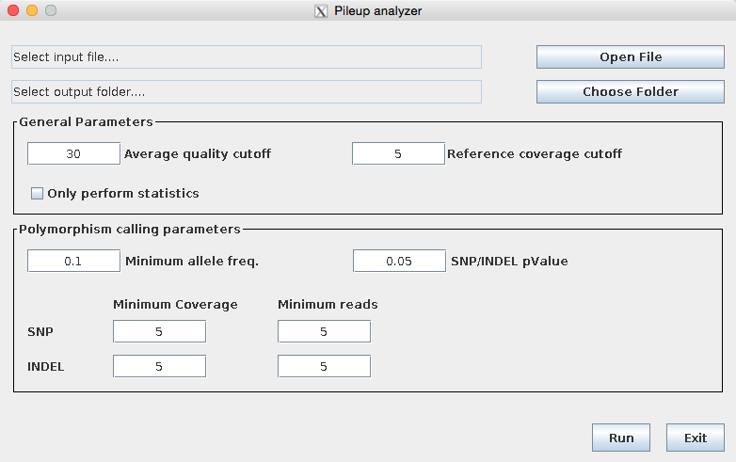

**Figure 3:** The pileup statistics GUI

Three elements will be generated in the pileup folder: (a) a Varscan formatted pileup file (namely “varscaPileup”), (b) a pileup statistics file (the suffix “_pileupStatistics” will be added to the original pileup file) and (c) the pileup folder that will be used in the remaining Altools programs (see below). The varscanPileup file is similar to the original pileup file but reports more information about the alignment (statistics of the called polymorphisms, allele frequencies, etc.). The _pileupStatistics file will output, for each chromosome, information such as the percentage of chromosome not covered by reads, frequency of SNPs and INDELs (both homo and heterozigous), G|C and A|T coverage (useful for assessing resequencing quality), frequency of transversions and transitions, reference (and target) genome base at polymorphic sites, A|T|G|C frequency in inserted and deleted DNA stretches.

**Coverage analyser**

Copy number variation (CNV) and presence/absence variation (PAV) can be calculated with this tool (Figure 4). Since losses or gains can be distinguished only by comparing two genomes this tool takes in input the pileup folder that has been previously generated on your resequencing experiments and a second pileup folder that has been generated on the reference genome (therefore you should obtain some resequencing data for the reference genome too, or simulate it).

Coverage analyser uses the R package dnacopy to segment the entire genome by considering the ratio between the coverage of your species and the coverage of the reference (that are retrieved from the two pileup folders). Please refer to the manuscript for algorithm that is used to call losses and gains.

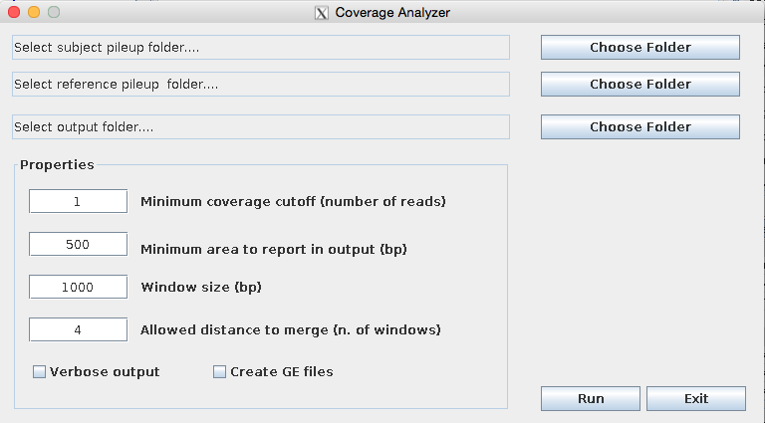

**Figure 4:** Coverage analyser GUI.

Coverage analyser takes in input the two pileup folders and the path of an output folder. Since the coverage ratio will be calculated on adjacent segments of DNA (e.g. by using an adjacent window approach) a window size should be set. In general the copy number variation refers to DNA stretches of approximately 1000bp. However you can select the minimum area to report in output (the minimum number of bases the structural variation should feature in order to be output). You can also decide to use only positions that feature a minimum coverage to be used in the calculation (minimum coverage cutoff). Finally the textbox “minimum distance to merge” will allow the merging of structural variations that are close to each other and therefore may actually represent the same SV. As a way of example let’s suppose you chose a window size of 50bp (that should give you a good compromise between accuracy and computation speed) and two gains are found in chromosome 1, the first one in position 1000 to 2000 and a second one in position 2100 to 4000; chances are that the two gains underlie the same SV. By setting the “minimum distance to merge” to 2 Coverage analyse will merge all the SVs that are 2*50bp apart and in the case of the reported example a copy number variation in the position 1000->4000 will be reported.

Windows that feature zero coverage in the target genome and coverage > 0 in the reference genome will be output in specific “zeroCoverage” files.

A file GE can be generated for all the found structural variations. Such files can be used with the Genic extractor tool (see below) to investigate whether annotated genes are included in the SV.

DNAcopy performs a smoothed segmentation for which segments that are less than 3 standard deviations apart are merged. Losses and gains are calculated additionally on these smoothed datasets.

In the output folder the files related to the losses, gains, zeroCoverage, both original and smoothed, and the corresponding GE files will be reported.

**Sliding analysis**

This tool (figure 5) will perform a sliding window analysis of coverage, SNPs and INDELs frequencies along the chromosomes. Sliding analysis just need the pileup folder and the path for an output folder. You can select the window size and step (an adjacent windows analysis will be performed for window size = window step). An additional cut off on the coverage can be set if desired.

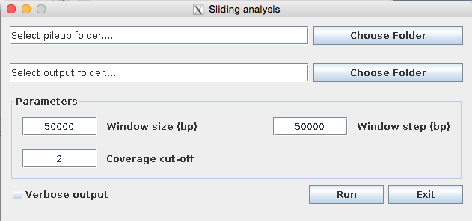

**Figure 5:** Sliding analysis GUI.

The output folder will contain the windows values for each chromosome in a tabular format and the corresponding plots (in pdf format).

**Large deletion finder**

This tool (figure 6) will allow you to find potential large deletions that can not be found be conventional short reads aligners such as bwa or bowtie. In order to run Large deletion finder you will be requested to provide sam formatted files that are relative to the alignment of paired ends on the reference.

A folder must be selected that contains such sam files relative together with an output file name prefix.

A deletion is called if, in the alignment, the insert size within two aligned paired end reads is in the range set in the GUI (with this range being higher than the expected insert size). Similarly an insertion is detected if the found insert is in the range reported in the GUI (but this time with a range that is lower than the hypothetical insert size). Several deletions can be found at the same chromosome position that are relatively close to each other and thus possibly underlie the same structural variation. The field “Maximum deletions distance to collapse” will allow you to merge those deletions whose first mates feature mapping positions that differs of the corresponding value (Figure 7). In this case the most upstream first mate end position and the most downstream second mate start position are considered to locate the deletion (in general setting a value close to the reads length proved to work very well with the simulated data).

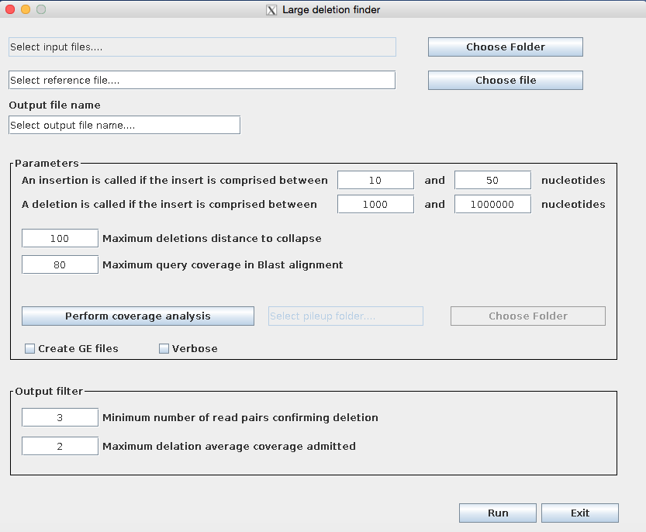

**Figure 6:** Large deletion finder GUI.

After this step is concluded the deletions putative starts and end positions are calculated. The corresponding coordinates are calculated merely contrasting the found and expected insert size. However the latest belong to a distribution rather than featuring a precise value. For this reason the calculated coordinates are refined in according to the following procedure.

Two ranges are defined that are 2000 nucleotides wide and centred on the putative start and end positions respectively (Figure 8). All read pairs for which at least one mate is mapped within such ranges are extracted from the sam formatted alignment file and a Blastn alignment of these reads is performed versus the reference genome. Reads that did not map originally on the reference possibly due to a broken alignment will produce hits at this stage that can be used to infer the real deletion boundaries. Only broken alignments whose length is lower than a specific percentage (“maximum query coverage in Blastn alignment) of the found maximum reads length are selected at this stage (generally the default value, 80, performed very well with the simulated data).



**Figure 7:** Merging procedure for the found deletions by Large deletion finder

If a genomic region is duplicated within the same chromosome a false deletion may be found due to the reads potentially mapping at multiple position. Large deletion finder executes the following test in order to investigate such a occurrence: the first 200 nucleotides after the deletion upstream breakpoint are extracted from the reference genome and blasted against it in order to search for additional alignments. In the output file additional fields are reported for each deletions indicating the position of such secondary alignments, their percentage of identity and alignment coverage. We define deletions that feature such supplementary fields such as ambiguous.

You can also perform a coverage analysis on the found deletions. This is particularly useful in understanding whether the deletion is homozygous (i.e. you are expected to find zero or near zero coverage), or to investigate whether the deleted portion is duplicated somewhere else in the genome. To activate this functionality simply press the “Perform coverage analysis” button and select the pileup folder for the alignment of the target genome.



**Figure 8:** three steps identification of the large deletions boundaries.

A minimum number of reads pairs that confirm the deletion can be chosen in order to output the polymorphism with this featuring limiting the number of deletions arising from random mapping of low quality reads.

Finally a maximum coverage can be set for the deletion to be output. This may be useful in limiting the occurrence of heterozygous deletions in the output. If you are interested in all the deletions inserting a very high value (e.g 100 times the expected average coverage) is advisable.

The software will output two files ( with suffixes _deletions.txt and _insertions.txt) together with the corresponding genic extractor files (if the “Generate GE files” box is ticked) in the folder where the selected alignment sam files are located.

**Polymorphism analyser**

With this tool (figure 9) you can investigate all polymorphisms (SNPs/INDELs) that occur in the genic regions. A file with several statistics such as the genic region (CDS, 3UTR, 5UTR), the position relative to the beginning of the sequence, the amino acid variation upon the SNP occurrence, the CDS frame shift upon INDEL occurrence will be reported in output.

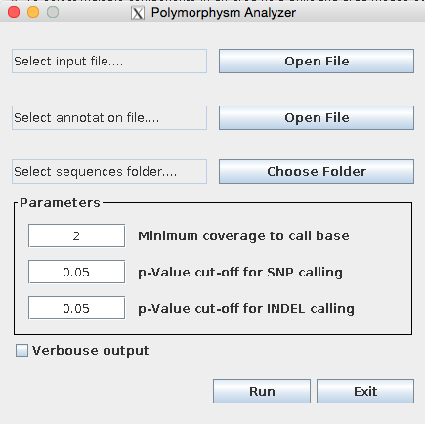

**Figure 9:** Polymorphisms analyser GUI.

You need to provide the pileup folder, an annotation file (gff format reporting the lines relative to “gene”, “mRNA”, “CDS”, and “UTR”), and a folder with 3 files (namely cds, 5utr and 3utr) with the fasta formatted sequences of the coding sequences and the two UTR portions. Names in the annotation file and the sequences files should, of course, match. Although several filters were applied during the generation of the pileup folder, additional constraints relative to the pValue and coverage of SNPs and INDELs can be set in the Polymorphisms analyser GUI.

**1:1 Alignment comparison**

This tool will allow you to indicate two pileup folders relative to two resequencing projects and receive back information about the peculiar polymorphisms (SNPs/INDELs) of the two analysed species, plus the common polymorphisms (Figure 10). You will need to choose a name for the two species, select the path for the corresponding pileup folders and indicate the path for the output folder.

The software will generate three files reporting polymorphisms chromosome, position and type that are found in (a) only the first species, (b) only the second species, (c) both species.

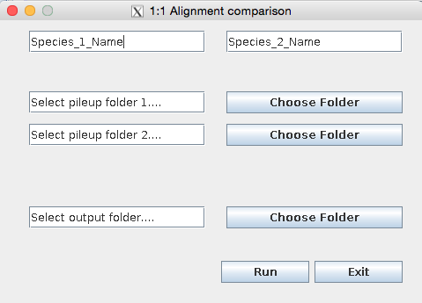

**Figure 10:** 1:1 Alignment comparison GUI

**Genic extractor**

This tool (figure 11) is useful when you want to investigate whether the found structural variations (either copy number variations, presence absence variations, or large deletions) contain annotated genic regions. Just provide the _GE file and the annotation gff3 file and press the “run” button. A file reporting the contained genes together with a flag (1=the genic portion is completely contained, 0 = the genic portion is only partially contained) will be output.

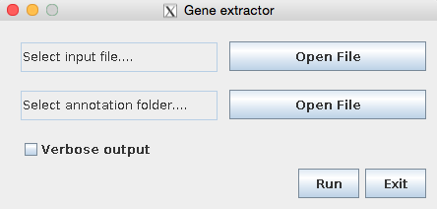

**Figure 11:** Genic extractor GUI